Member to Member Transfers Configuration Worksheet

Refer to BANNO.M2MTRANSFERS.V4.CFG

Required Criteria
Users must have a Preference Access Type 3 (Transfer to Any Account) record on their account to use the program.
Info Type | Description | CU Response
Preference Access Type 3 | Identify if Preference Access Type 3 (Transfer to Any Account) records are used currently.  Valid Values: Yes or No
Creating Preference Access Type 3 Records | If Preference Access Type 3 is set to “No”, determine if you want to add these records manually or if you would like to use our batch job to automatically add these records to every open account.  This job can be run one time or scheduled to run daily to continue to create these records for new accounts going forward.  Valid Values: Manual, Batch Job-One Time, or Batch Job-Scheduled

Spanish Language Support
This parameter is only used if the Credit Union is contracted for Banno Spanish Language Support.
Parameter Name | Parameter Description | Default Value | CU Response
Spanish Language Support | Set the Spanish Language Support parameter to TRUE if Spanish versions of soft text and error messages should be displayed to the user when a Spanish supported browser/device is being used.  Valid Values: TRUE or FALSE | SLS: FALSE | SLS:

Memo Mode Transfers
There are a few things to consider when determining whether or not to allow Member to Member (M2M) transfers during memo mode.
M2M transfers are not posted to Symitar during memo mode but rather posted once Symitar is back on host. Therefore, transactions submitted during memo mode could be requested by the user for the current day, but when the system comes back on host, depending on your CU's Goodnight job configuration, the system date may have changed to the next day. This could result in those transactions not being processed.
A similar scenario occurs for limits. Since transactions are not posted during memo mode, a user could perform transactions that exceed their limit(s) since the aggregate totals are not updated until the transactions are posted.
Refer to eDocs for information about Memo Mode. Memo Post Mode: Symitar eDocs> search “memo mode”> select “Memo Post Mode”.
Parameter Name | Parameter Description | Default Value | CU Response
Allow Memo Mode Transfers | Determine if M2M Transfers will be allowed when Symitar is in memo mode.  Valid Values: TRUE or FALSE | MMXF: TRUE | MMXF:
Error Display Message | If Allow Memo Mode Transfers is set to “FALSE”, enter the message to be displayed to the Banno user when a M2M Transfer is attempted during memo mode.  Example: “Member to Member transfers are not available due to system maintenance. Please try again later.”  Valid Values: Any descriptive text. | EDM500: NONE | EDM500:

Account Exclusions
Account types or account level warnings that disqualify the member from completing Member to Member Transfers.
Parameter Name | Parameter Description | Default Value | CU Response
Ineligible Account Types | Enter a list containing only numeric values along with commas or dashes. Any account that is one of the account types in the list will not be allowed to use this functionality.  Valid Values: 0-9999 or Blank  Blank = nothing to exclude | IAT: NONE | IAT:
Ineligible Donor Account Warning Codes | Enter a list containing only numeric values along with commas or dashes. Any account with one of the Account level warning codes in the list will not be allowed to send funds using this functionality.  Valid Values: 1-999 or NONE  None = nothing to exclude | IAW: NONE | IAW:
Ineligible Recipient Account Warning Codes | Enter a list containing only numeric values along with commas or dashes. Any account with one of the Account level warning codes in the list will not be allowed to receive funds using this functionality.  Valid Values: 1-999 or NONE  None = nothing to exclude | IRAW: NONE | IRAW:

Enforcing and Setting Transfer Limits
Determine if the program should enforce daily transfer limits. If you enforce limits, then EITHER the member’s Preference record daily transfer limits set by the CU or the global limits defined by this worksheet will be checked and honored based on the following chart. If you elect to NOT enforce daily limits, then settings related to daily limits (global or Preference record) will be ignored.
Global Limit Setting | Preference Record Limit Setting | Limit Used
0 or blank | 0 | Program halted and error displayed
>0 | 0 | Global Limit
0 | >0 | Preference Record Limit
>0 | >0 | Preference Record Limit

The Preference record fields which control the daily limits: Transfer Count Limit, Transfer Limit, and Maximum Transfer. Preference record limits can be used for member exceptions or one-off scenarios, which will override the global limits.
Parameter Name | Parameter Description | Default Value | CU Response
Enforce Limits | Determine if the program should enforce daily M2M transfer limits.  Valid Values: TRUE or FALSE | EL: FALSE | EL:
Global Count Limit | If Enforce Limits is set to “TRUE”, enter the maximum number of transfers allowed per day.  Valid Values: 0-9999 | GCL: 0 | GCL:
Global Amount Limit | If Enforce Limits is set to “TRUE”, enter the total aggregate dollar amount allowed per day.  Valid Values: 0.00-999,999.99 | GAL: 0.00 | GAL:
Global Individual Transfer Limit | If Enforce Limits is set to “TRUE”, enter the dollar amount limit allowed for each individual transfer.  Valid Values: 0.00-999,999.99 | GIL: 0.00 | GIL:

Eligible ‘Transfer From’ Shares
Determine the shares eligible to ‘Transfer from’.
Parameter Name | Parameter Description | Default Value | CU Response
Cross Account Access | Determine if cross accounts will be included in the ‘Transfer from’ list of accounts. (A cross account is an alternate account a user has access to via Preference Access Record).  Valid Values: TRUE or FALSE | XA: FALSE | XA:
Eligible Transfer From Types | Determine if the ‘Transfer from’ list will include Shares, Loans, or Both.  Valid Values: SHARES, LOANS, or BOTH | XT: SHARES | XT:

Allow Editing of Manually Created Transfers
Manually created transfers are Share Transfer Type 3 records added in Symitar Account Manager by CU staff.
Parameter Name | Parameter Description | Default Value | CU Response
Allow Edit of Manually Created Transfers | Determine if the program will allow the member to edit manually created Share Transfer Type 3 records. Listing specific user numbers will only allow the user to edit transfer records created by that user, in addition to those created by this program.  Valid Values: TRUE , FALSE, or 1-9999 | AE:FALSE | AE:
Eligible ‘Transfer To’ Shares
Determine the shares eligible to ‘Transfer to’.
Parameter Name | Parameter Description | Default Value | CU Response
Allow Transfers to Clubs | Determine if the program will allow transfers to Club shares (share code =3).  Valid Values: TRUE or FALSE | ACL: FALSE | ACL:
Allow Transfers to Certificates | Determine if the program will allow transfers to Certificate shares (share code =2).  Valid Values: TRUE or FALSE | ACE: FALSE | ACE:

Transaction Description/ Comment
Entering a comment will prepend to any immediate one-time transfer.
Parameter Name | Parameter Description | Default Value | CU Response
Transaction Description/ Comment Default | Enter a comment to prepend to any immediate one-time transfer.  Valid Values: Any descriptive text.  Recommend a maximum 19 characters. | TC: M2M Transfer | TC:

Overriding UI Hard Coded Instructions
Entering text in these parameters will override the default instructions. These are the labels that explain what the user would enter in the Member Name or Share/ Loan ID fields.
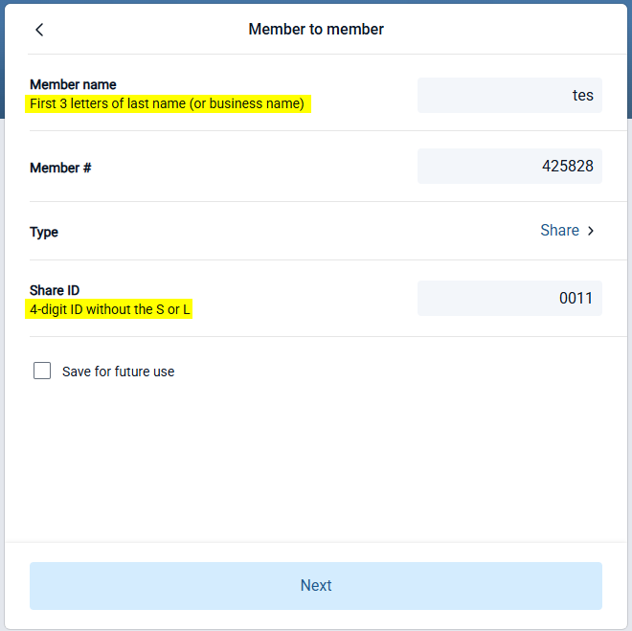
Parameter Name | Parameter Description | Default Value | CU Response
Label Member Name Sub-Title | Enter text here to override the UI hard coded member name instructions. This is a label that explains what the user would enter in the Member Name field when adding a new M2M Transfer. Max character entry for this text is 80 characters.  Valid Value: Any descriptive text. | LBLMN: First 3 letters of last name (or business name)  LBLMN_SP: CU to provide Spanish text to display | LBLMN:  LBLMN_SP:
Label ID Sub-Title | Enter text here to override the UI hard coded ID description. This is a label that explains what number to enter when identifying the Share/ Loan ID. Max character entry for this text is 80 characters.  Valid Value: Any descriptive text. | LBLID: 2-digit/ 4-digit ID without the S or L  LBLID_SP: CU to provide Spanish text to display. | LBLID:  LBLID_SP:

Member Verify
This verification occurs when a user enters another member’s account information to validate before initiating a transfer. The settings below will help monitor and limit repeated failed verification attempts, reducing the risk of unauthorized access attempts or excessive guessing of member information.
Parameter Name | Description | Default Value | CU Response
Member Verify Account Tracking Type | This setting defines the Account Tracking Type that will be used to record invalid Member Verification attempts. “0” will prevent invalid attempts from being recorded in the Tracking Record (not recommended).  Valid Values: 0, 30-99 | MVACTT: 0 | MVACTT:
Max Member Verify Invalid Attempts | This setting controls the maximum number of failed Member Verification attempts allowed within a defined time period before Member Verification is temporarily blocked. “9999” will allow an unlimited number of attempts (not recommended).  Valid Values: 0-20, 9999 | MVMA: 6 | MVMA:
Member Verify Invalid Attempts Window | This setting defines the rolling time period, in hours, used to evaluate failed Member Verification attempts.  Valid Values: 1-48 | MVIAW: 24 | MVIAW:

Member to Member Transfers Report
The Member to Member Transfers Report provides details about one-time immediate transfers, as well as future-dated and recurring transfers that have been scheduled by members using the Member to Member Transfers PowerOn. The report is generated by a batch PowerOn in Symitar.
Select one of the report options below and identify if Banno or the Credit Union will complete the installation and setup.
Report Options | Description | CU Response
M2M Transfers Report | Determine if the CU would like to utilize the M2M Transfers Report. If “No”, the M2M Transfers Report will not be installed for the CU and the remaining responses in this section may be skipped. If “Yes”, select one of the Report Options below and indicate who should complete the setup.  Valid Values: No or Yes
Demand Use Only | The M2M Transfers Report will be installed for demand use only and can be run as needed.  Valid Values: Banno Setup or CU Setup
Report Automation | A Batch Job File will be set up to automatically run based on a chosen frequency/recurring basis with the report available in Print Control.  Valid Values: Banno Setup or CU Setup

Banno Parameters
The following will be used for setup in Banno.
Info Type | Description | Default | CU Response
Link Title | Enter the text for the link the members will see to begin the process. | Member Transfer
Banno Live? | Is the CU currently LIVE to members with either Banno Online or Banno Mobile?  Enter “Yes” or “No”
Test Users | If Banno Live? Is “YES”, list Banno usernames of users that will test M2M Transfers before enabling the feature for all users.

